## Overview

Next up, you will add to and style the content section of your website. Feel free to follow the design we specify below or add your own spin.

## Instructions

**Part 1: Update the HTML**

1. Add the content class to the container-fluid <div>.
2. Next, add a title to this <div> by adding a <h2> tag with the text **Why we're better**.
   * Give the <h2> tag the sectionHeading class.
3. Add the valueProp class to the row <div>.
4. Within the row <div>, add the imageContainer class to the <div> that contains an image.
5. Note that the design has two more rows in this section. Duplicate the first row twice. Update the images and copy for each duplicated row.

**Part 2: Update the CSS**

1. Add the following CSS to style the valueProp and sideAccent classes:

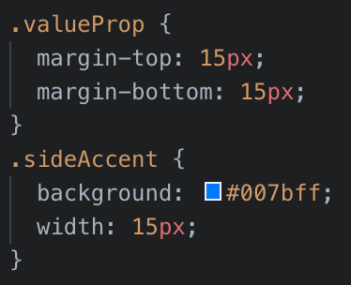

1. Next, add the following to style the imageContainer class and images inside that element:

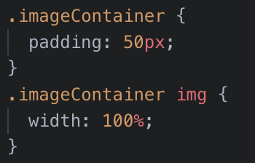

1. Congrats! You should now have three rows of content on your template.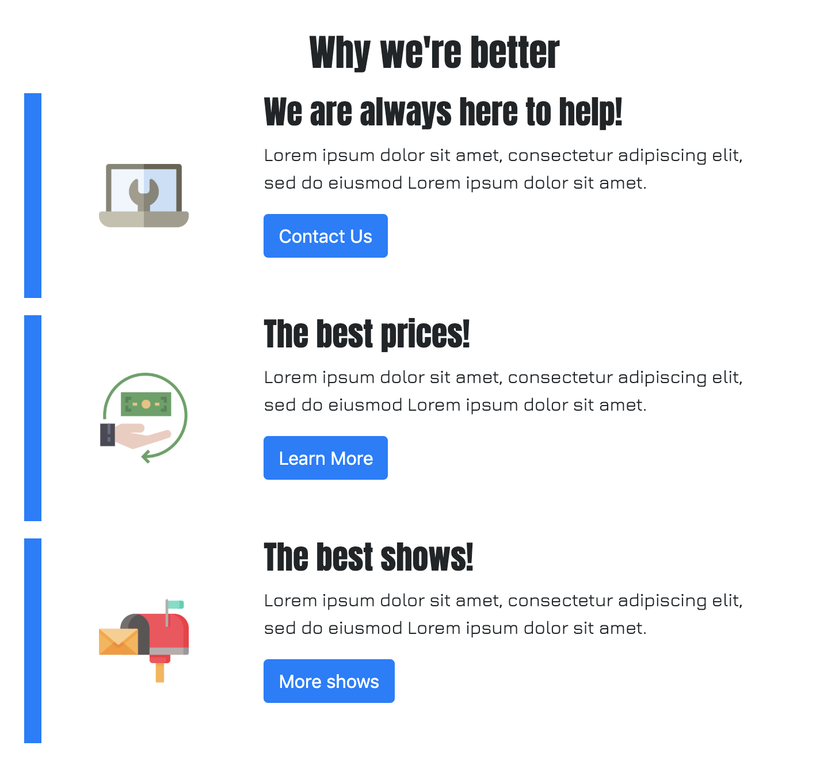

Great work!